
Tripoli Motor Testing Division
223 NC Highway 54 West
Chapel Hill, NC 27514
(919) 357 5681 (c)
May 10, 2021

Gary Rosenfield
RCS Rocket Motor Components, Inc.
2113 West 850 North Street
Cedar City, UT 84721

Dear Mr. Rosenfield,

The Q-jet by Aerotech B6W single-use motor was tested on April 12 and May 8, 2021 and complies with NFPA 1125. The motor is certified for hobby rocketry use by the members of the Tripoli Rocketry Association and all approving organizations with reciprocal certifying agreements.

Motor Manufacturer RCS Rocket Motor Components, Inc.
Manufacturer’s Designation B6W-4,6 [single use]
Propellant FWL
TMT Nomenclature 5 B4

Diameter 0.692” 18 mm
Overall Length 3.166” 79.15 mm
Casing Length 2.717” 69.01 mm

Loaded Mass 0.0403 lb 18.29 g
Propellant Mass 0.0062 lb* 2.8 g*
Burnout Mass 0.0278 lb 12.59 g
* = data provided by manufacturer

Burn time 1.169 ± 0.068 sec

Total Impulse 1.110 ± .053 lbf.s 4.865 ± .210 N.s
Max Impulse 2.052 ± .188 lbf 9.127 ± .838 N
Average Impulse .948 ± .088 lbf 4.222 ± .388 N
Number of Motors Tested 10

Nominal Measured
Delay Time Data 4 s 4.412, 4.570, 4.484 s
6 s 6.034, 6.226, 6.009, 5.692 5.435, 6.424, 6.106 s

Casing Temp. [NFPA 1125 7.4.1] Passed

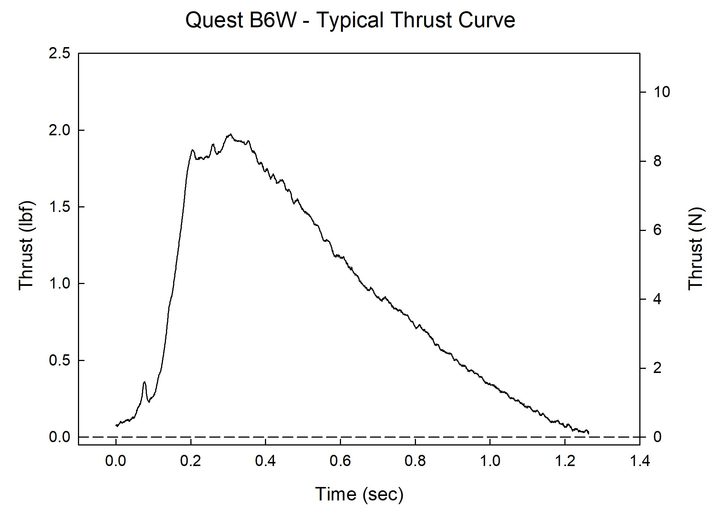

Sincerely,

Alan C. Whitmore
Chair, Tripoli Motor Testing

